W04 Team Activity: Foundation Programs Design
Program #1 - YouTube Videos (Abstraction)
1) Classes (and responsibilities)
Minimum classes (from your team):
- Video: stores video data and its list of comments; can compute how many comments it has.
- Comment: stores the commenter name and the comment text.
Optional (helpful but not required):
- VideoLibrary / Program (orchestrator): creates the videos, adds comments, and prints output (often this logic lives in Program.cs, not necessarily as a separate class).
2) Methods (behaviors)
Comment
- Comment(string commenterName, string text) (constructor)
- GetCommenterName(): string (optional)
- GetText(): string (optional)
- ToString(): string → returns something like "Name: text" (optional but convenient)
Video
- Video(string title, string author, int lengthSeconds) (constructor)
- AddComment(Comment comment): void
- GetNumberOfComments(): int
- GetComments(): List<Comment> (or return a copy / read-only)
- GetDisplayText(): string (optional) → builds the line you print (title, author, length, #comments)
Program (main)
- Main(string[] args): void
- Create 3–4 videos
- Add 3–4 comments per video
- Loop and print all required output
3) Attributes (member variables)
Comment
- _commenterName: string
- _text: string
Video
- _title: string
- _author: string
- _lengthSeconds: int
- _comments: List<Comment>

4) Class diagram (simple UML)
classDiagram
class Video {
-string _title
-string _author
-int _lengthSeconds
-List~Comment~ _comments
+Video(title, author, lengthSeconds)
+void AddComment(Comment comment)
+int GetNumberOfComments()
+List~Comment~ GetComments()
+string GetDisplayText()
}

class Comment {
-string _commenterName
-string _text
+Comment(commenterName, text)
+string ToString()
}
Video "1" --> "0..*" Comment : contains
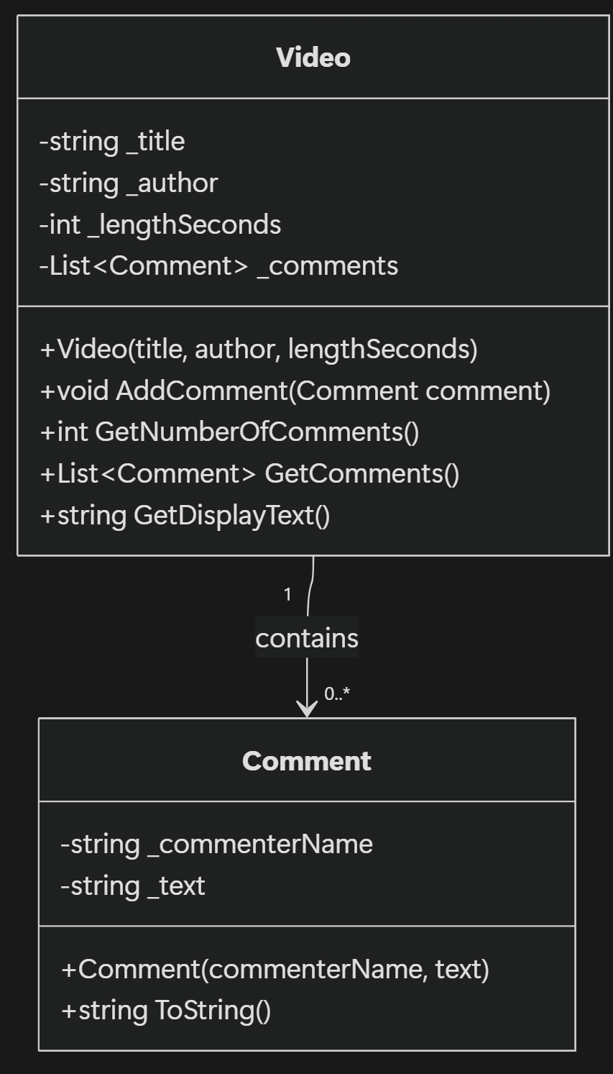
5) Program flow (how it runs / how methods relate)
Mermaid
flowchart TD
A[Start Main] --> B[Create List<Video>]
B --> C[Create Video 1..4]
C --> D[For each Video: add 3..4 Comment]
D --> E[Loop through videos]
E --> F[Print title, author, length, #comments]
F --> G[Loop comments of video]
G --> H[Print each comment]
H --> E
E --> I[End]
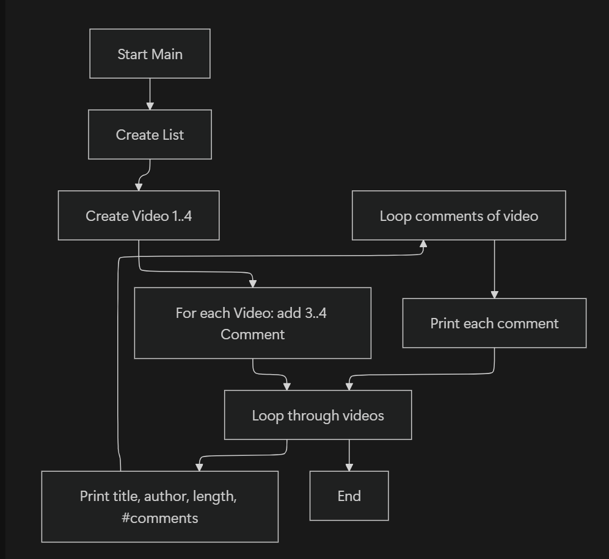

Program #2 - Online Ordering (Encapsulation)
1) Classes (and responsibilities)
Required classes (from your team):
- Product: name, id, price, quantity; computes its total cost.
- Address: stores full address; knows if it’s in the USA; returns formatted address string.
- Customer: name + address; knows whether they live in the USA (without checking the country directly).
- Order: list of products + customer; computes totals; generates packing and shipping labels.
Optional (only if you want to improve design):
- ReceiptPrinter / OrderService: separate printing from calculation (not required).
2) Methods (behaviors)
Product
- Product(string name, string productId, double price, int quantity)
- GetTotalCost(): double → price * quantity
- (Optional) getters like
- GetName(), GetProductId(), etc.
Address
- Address(string street, string city, string stateOrProvince, string country)
- IsInUSA(): bool
- GetFullAddress(): string → formatted with line breaks
Customer
- Customer(string name, Address address)
- LivesInUSA(): bool → calls
address.IsInUSA()
- GetName(): string
- GetAddress(): Address or GetShippingAddressString(): string (choose one approach)
Order
- Order(Customer customer)
- AddProduct(Product product): void
- GetShippingCost(): double → 5 if USA, 35 otherwise
- GetTotalCost(): double → sum of products + shipping
- GetPackingLabel(): string → list products (name - id)
- GetShippingLabel(): string → customer name + full address
Program
(main)
- Main(string[] args): void
  - Create 2–3 orders with different customers (USA and non-USA)
  - Add products to each order
  - Print packing label, shipping label, and total cost for each order
3) Attributes (member variables)
Product
- _name: string
- _productId: string
- _price: double
- _quantity: int
Address
- _street: string
- _city: string
- _stateOrProvince: string
- _country: string
Customer
- _name: string
- _address: Address
Order
- _products: List<Product>
- _customer: Customer
4) Class diagram (simple UML)
classDiagram
class Product {
-string _name
-string _productId
-double _price
-int _quantity
+Product(name, productId, price, quantity)
+double GetTotalCost()
+string GetName()
+string GetProductId()
}
class Address {
-string _street
-string _city
-string _stateOrProvince
-string _country
+Address(street, city, stateOrProvince, country)
+bool IsInUSA()
+string GetFullAddress()
}
class Customer {
-string _name
-Address _address
+Customer(name, address)
+bool LivesInUSA()
+string GetName()
+Address GetAddress()
}

class Order {
-List~Product~ _products
-Customer _customer
+Order(customer)
+void AddProduct(Product product)
+double GetShippingCost()
+double GetTotalCost()
+string GetPackingLabel()
+string GetShippingLabel()
}
Order "1" --> "1" Customer : has
Customer "1" --> "1" Address : has
Order "1" --> "1..*" Product : contains

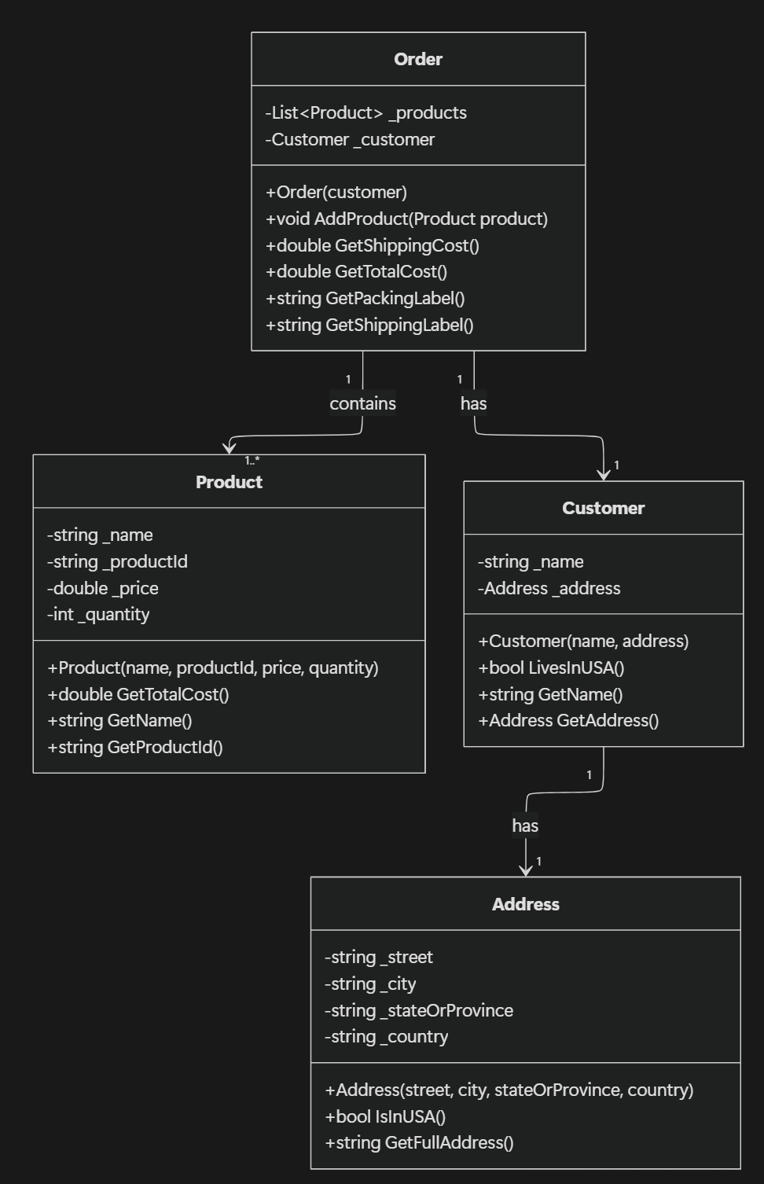
5) Program flow (how it runs / method relationships)
flowchart TD
A[Start Main] --> B[Create Customer + Address]
B --> C[Create Order(customer)]
C --> D[Create Products]
D --> E[order.AddProduct(product) ...]
E --> F[Print Packing Label]
F --> G[Order.GetPackingLabel()<br>loops products -> name + id]
E --> H[Print Shipping Label]
H --> I[Order.GetShippingLabel()<br>customer name + address.GetFullAddress()]
E --> J[Print Total Cost]
J --> K[Order.GetTotalCost()]
K --> L[Sum products: product.GetTotalCost()]
K --> M[Add shipping: Order.GetShippingCost()]
M --> N[Order uses customer.LivesInUSA() -> address.IsInUSA()]
N --> O[End]

